Program 1

Aim: Write code for min min scheduling algorithm

import matplotlib.pyplot as plt

import numpy as np

import pandas as pd

processes = ['P1', 'P2', 'P3', 'P4']

machines = ['M1', 'M2', 'M3']

execution_times = np.array([[2, 4, 6], [5, 3, 4], [4, 2, 7], [6, 5, 3]])

completion_times = {machine: 0 for machine in machines}

schedule = []

remaining_processes = set(range(len(processes)))

while remaining_processes:

    min_time = float('inf')

    selected_process = None

    selected_machine = None

    for process_idx in remaining_processes:

        for machine_idx, machine in enumerate(machines):

            exec_time = execution_times[process_idx, machine_idx]

            total_time = completion_times[machine] + exec_time

            if total_time < min_time:

                min_time = total_time

                selected_process = process_idx

                selected_machine = machine_idx

    process_name = processes[selected_process]

    machine_name = machines[selected_machine]

    exec_time = execution_times[selected_process, selected_machine]

    start_time = completion_times[machine_name]

    completion_times[machine_name] += exec_time

    schedule.append((machine_name, process_name, start_time, exec_time))

    remaining_processes.remove(selected_process)

schedule_df = pd.DataFrame(schedule, columns=['Machine', 'Process', 'Start', 'Duration'])

schedule_df['End'] = schedule_df['Start'] + schedule_df['Duration']

print("Schedule:")

print(schedule_df[['Process', 'Machine', 'Start', 'End']])

fig, ax = plt.subplots(figsize=(10, 6))

for machine, process, start, exec_time in schedule:

    ax.barh(machine, exec_time, left=start, height=0.5, color="white", edgecolor='black')

    ax.text(start + exec_time / 2, machines.index(machine), process, ha='center', va='center', color='black')

ax.set_xlabel('Time')

ax.set_title('Gantt Chart for Min-Min Scheduling')

ax.grid(axis='x', linestyle='--', alpha=0.5)

plt.tight_layout()

plt.show()

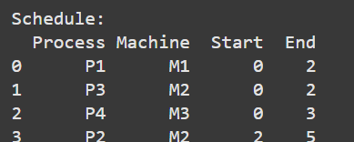

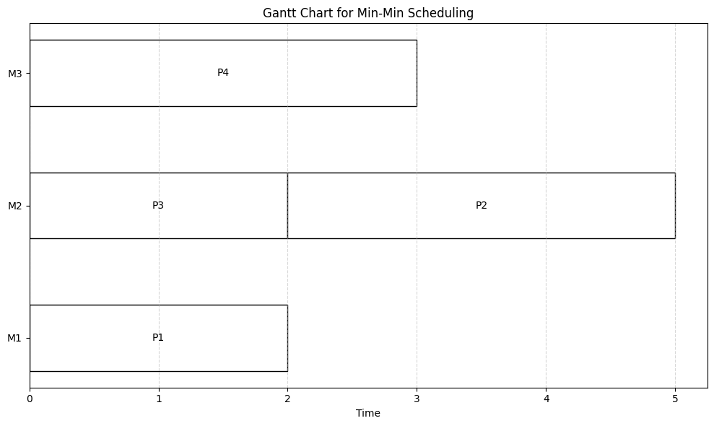

Program 2

Aim: Write code for min min scheduling algorithm with Arrival Time

import numpy as np

import matplotlib.pyplot as plt

import pandas as pd

num_machines = 3

num_processes = 4

execution_times = np.array([

    [12, 15, 9],

    [8, 18, 13],

    [14, 11, 10],

    [6, 7, 12]

])

arrival_times = [0, 3, 7, 2]

machine_available_times = [0] * num_machines

completion_times = [0] * num_processes

schedule = []

unscheduled_processes = list(range(num_processes))

while unscheduled_processes:

    min_completion_time = float('inf')

    selected_process = -1

    selected_machine = -1

    for process in unscheduled_processes:

        process_arrival = arrival_times[process]

        for machine in range(num_machines):

            start_time = max(machine_available_times[machine], process_arrival)

            completion_time = start_time + execution_times[process][machine]

            if completion_time < min_completion_time:

                min_completion_time = completion_time

                selected_process = process

                selected_machine = machine

    process_arrival = arrival_times[selected_process]

    start_time = max(machine_available_times[selected_machine], process_arrival)

    end_time = start_time + execution_times[selected_process][selected_machine]

    machine_available_times[selected_machine] = end_time

    completion_times[selected_process] = end_time

    schedule.append({

        'Process': f'P{selected_process}',

        'Machine': f'M{selected_machine}',

        'Start': start_time,

        'End': end_time

    })

    unscheduled_processes.remove(selected_process)

schedule_df = pd.DataFrame(schedule)

print("Schedule:")

print(schedule_df)

fig, gnt = plt.subplots(figsize=(10, 6))

gnt.set_xlabel('Time')

gnt.set_ylabel('Machines')

gnt.set_yticks([1, 2, 3])

gnt.set_yticklabels(['M0', 'M1', 'M2'])

gnt.set_title('Gantt Chart for Min-Min Scheduling Algorithm')

colors = ['white', 'white', 'white', 'white']

for i, task in enumerate(schedule):

    machine_index = int(task['Machine'][1]) + 1  # Convert machine name to index

    gnt.barh(machine_index, left=task['Start'], width=task['End'] - task['Start'], color=colors[i % len(colors)], edgecolor='black')

    gnt.text((task['Start'] + task['End']) / 2, machine_index, task['Process'], va='center', ha='center', color='black')

plt.show()

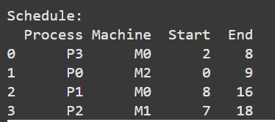

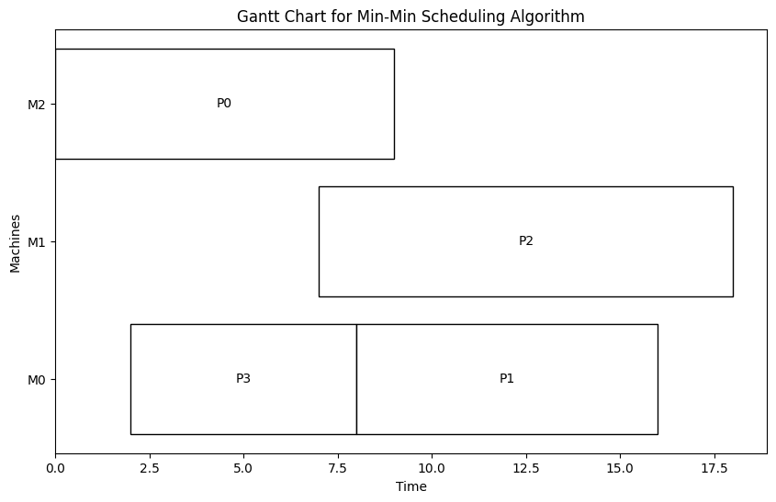

Program 3

Aim: Write code for min max scheduling algorithm

import matplotlib.pyplot as plt

import numpy as np

import pandas as pd

processes = ['P1', 'P2', 'P3', 'P4']

machines = ['M1', 'M2', 'M3']

execution_times = np.array([[2, 4, 6], [5, 3, 4], [4, 2, 7], [6, 5, 3]])

completion_times = {machine: 0 for machine in machines}

schedule = []

remaining_processes = set(range(len(processes)))

while remaining_processes:

    min_exec_times = {process_idx: min(execution_times[process_idx]) for process_idx in remaining_processes}

    max_of_mins_process = max(min_exec_times, key=min_exec_times.get)

    selected_process = max_of_mins_process

    min_time = float('inf')

    selected_machine = None

    for machine_idx, machine in enumerate(machines):

        exec_time = execution_times[selected_process, machine_idx]

        total_time = completion_times[machine] + exec_time

        if total_time < min_time:

            min_time = total_time

            selected_machine = machine_idx

    process_name = processes[selected_process]

    machine_name = machines[selected_machine]

    exec_time = execution_times[selected_process, selected_machine]

    start_time = completion_times[machine_name]

    completion_times[machine_name] += exec_time

    schedule.append((machine_name, process_name, start_time, exec_time))

    remaining_processes.remove(selected_process)

schedule_df = pd.DataFrame(schedule, columns=['Machine', 'Process', 'Start', 'Duration'])

schedule_df['End'] = schedule_df['Start'] + schedule_df['Duration']

print("Schedule:")

print(schedule_df[['Process', 'Machine', 'Start', 'End']])

fig, ax = plt.subplots(figsize=(10, 6))

for machine, process, start, exec_time in schedule:

    ax.barh(machine, exec_time, left=start, height=0.5, color="white", edgecolor='black')

    ax.text(start + exec_time / 2, machines.index(machine), process, ha='center', va='center', color='black')

ax.set_xlabel('Time')

ax.set_title('Gantt Chart for Modified Min-Min Scheduling')

ax.grid(axis='x', linestyle='--', alpha=0.5)

plt.tight_layout()

plt.show()

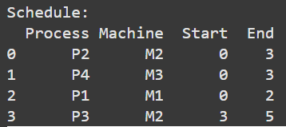

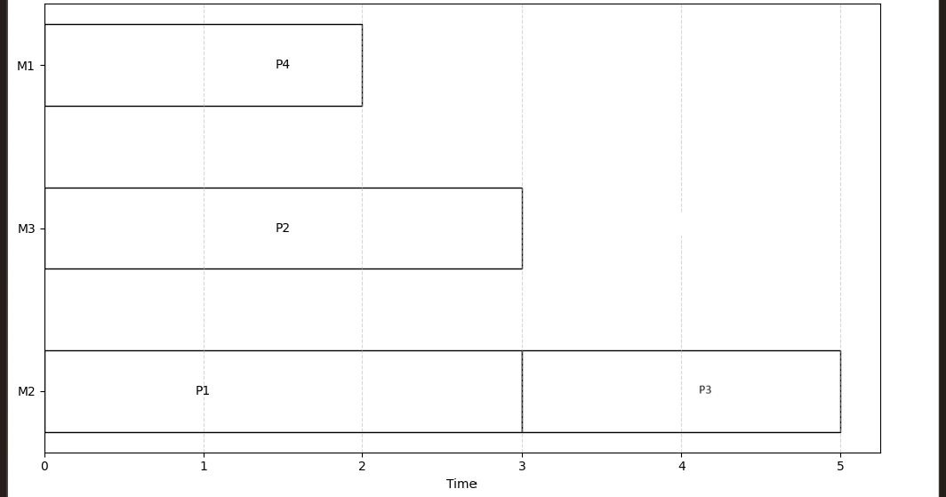

Program 4

Aim: Write code for min max scheduling algorithm with arrival time

import matplotlib.pyplot as plt

import numpy as np

import pandas as pd

processes = ['P1', 'P2', 'P3', 'P4']

machines = ['M1', 'M2', 'M3']

execution_times = np.array([[2, 4, 6], [5, 3, 4], [4, 2, 7], [6, 5, 3]])

arrival_times = [0, 1, 2, 3]

completion_times = {machine: 0 for machine in machines}

schedule = []

remaining_processes = set(range(len(processes)))

current_time = 0

while remaining_processes:

    available_processes = {p for p in remaining_processes if arrival_times[p] <= current_time}

    if not available_processes:

        current_time = min(arrival_times[p] for p in remaining_processes)

        continue

    min_exec_times = {process_idx: min(execution_times[process_idx]) for process_idx in available_processes}

    max_of_mins_process = max(min_exec_times, key=min_exec_times.get)

    selected_process = max_of_mins_process

    min_time = float('inf')

    selected_machine = None

    for machine_idx, machine in enumerate(machines):

        exec_time = execution_times[selected_process, machine_idx]

        total_time = max(completion_times[machine], current_time) + exec_time

        if total_time < min_time:

            min_time = total_time

            selected_machine = machine_idx

    process_name = processes[selected_process]

    machine_name = machines[selected_machine]

    exec_time = execution_times[selected_process, selected_machine]

    start_time = max(completion_times[machine_name], current_time)

    completion_times[machine_name] = start_time + exec_time

    schedule.append((machine_name, process_name, start_time, exec_time))

    remaining_processes.remove(selected_process)

    current_time = start_time + exec_time

schedule_df = pd.DataFrame(schedule, columns=['Machine', 'Process', 'Start', 'Duration'])

schedule_df['End'] = schedule_df['Start'] + schedule_df['Duration']

print("Schedule:")

print(schedule_df[['Process', 'Machine', 'Start', 'End']])

fig, ax = plt.subplots(figsize=(10, 6))

for machine, process, start, exec_time in schedule:

    ax.barh(machine, exec_time, left=start, height=0.5, color="white", edgecolor='black')

    ax.text(start + exec_time / 2, machines.index(machine), process, ha='center', va='center', color='black')

ax.set_xlabel('Time')

ax.set_title('Gantt Chart for Min Max Scheduling with Arrival Times')

ax.grid(axis='x', linestyle='--', alpha=0.5)

plt.tight_layout()

plt.show()

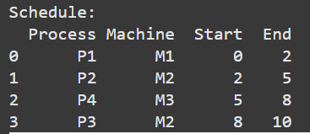

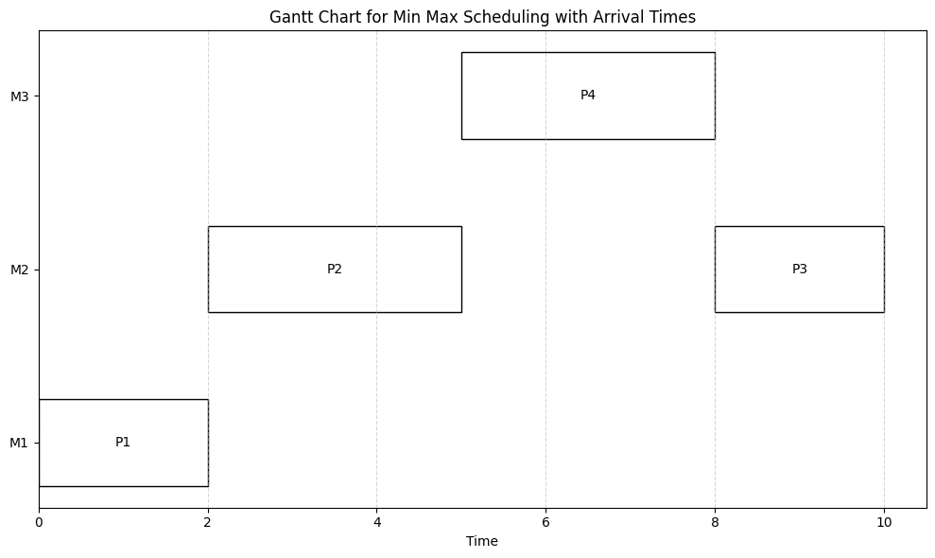

Program 5

Aim: Write code for round robin scheduling algorithm

import matplotlib.pyplot as plt

import pandas as pd

processes = ['P1', 'P2', 'P3', 'P4', 'P5', 'P6']

machines = ['M1', 'M2', 'M3']

execution_times = [3, 2, 4, 1, 5, 3]

arrival_times = [0, 1, 2, 3, 4, 5]

completion_times = {machine: 0 for machine in machines}

schedule = []

machine_idx = 0

remaining_processes = set(range(len(processes)))

while remaining_processes:

    available_processes = {p for p in remaining_processes if arrival_times[p] <= completion_times[machines[machine_idx]]}

    if not available_processes:

        current_machine_time = min(arrival_times[p] for p in remaining_processes)

        available_processes = {p for p in remaining_processes if arrival_times[p] <= current_machine_time}

    selected_process = min(available_processes, key=lambda p: arrival_times[p])

    machine_name = machines[machine_idx]

    process_name = processes[selected_process]

    exec_time = execution_times[selected_process]

    start_time = max(completion_times[machine_name], arrival_times[selected_process])

    completion_times[machine_name] = start_time + exec_time

    schedule.append((machine_name, process_name, start_time, exec_time))

    machine_idx = (machine_idx + 1) % len(machines)

    remaining_processes.remove(selected_process)

schedule_df = pd.DataFrame(schedule, columns=['Machine', 'Process', 'Start', 'Duration'])

schedule_df['End'] = schedule_df['Start'] + schedule_df['Duration']

print("Schedule:")

print(schedule_df[['Process', 'Machine', 'Start', 'End']])

fig, ax = plt.subplots(figsize=(10, 6))

for machine, process, start, exec_time in schedule:

    ax.barh(machine, exec_time, left=start, height=0.5, color="white", edgecolor='black')

    ax.text(start + exec_time / 2, machines.index(machine), process, ha='center', va='center', color='black')

ax.set_xlabel('Time')

ax.set_title('Gantt Chart for Overlapping Round Robin Scheduling')

ax.grid(axis='x', linestyle='--', alpha=0.5)

plt.tight_layout()

plt.show()

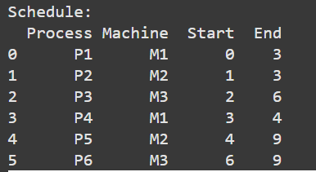

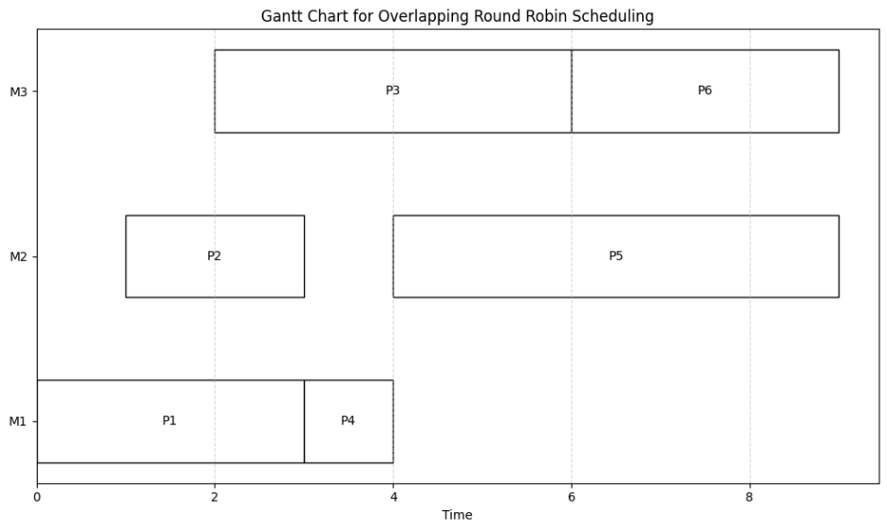

Program 6

Aim: Write code for weighted round robin scheduling algorithm

import matplotlib.pyplot as plt

import pandas as pd

processes = ['P1', 'P2', 'P3', 'P4', 'P5', 'P6']

machines = ['M1', 'M2', 'M3']

execution_times = [3, 2, 4, 1, 5, 3]

arrival_times = [0, 1, 2, 3, 4, 5]

machine_weights = [2, 1, 2]

completion_times = {machine: 0 for machine in machines}

schedule = []

current_time = 0

remaining_processes = set(range(len(processes)))

machine_idx = 0

machine_usage_count = 0

while remaining_processes:

    available_processes = {p for p in remaining_processes if arrival_times[p] <= current_time}

    if not available_processes:

        current_time = min(arrival_times[p] for p in remaining_processes)

        continue

    selected_process = min(available_processes, key=lambda p: arrival_times[p])

    machine_name = machines[machine_idx]

    process_name = processes[selected_process]

    exec_time = execution_times[selected_process]

    start_time = max(completion_times[machine_name], arrival_times[selected_process])

    completion_times[machine_name] = start_time + exec_time

    schedule.append((machine_name, process_name, start_time, exec_time))

    remaining_processes.remove(selected_process)

    current_time = start_time + exec_time

    machine_usage_count += 1

    if machine_usage_count >= machine_weights[machine_idx]:

        machine_idx = (machine_idx + 1) % len(machines)

        machine_usage_count = 0

schedule_df = pd.DataFrame(schedule, columns=['Machine', 'Process', 'Start', 'Duration'])

schedule_df['End'] = schedule_df['Start'] + schedule_df['Duration']

print("Schedule:")

print(schedule_df[['Process', 'Machine', 'Start', 'End']])

fig, ax = plt.subplots(figsize=(10, 6))

for machine, process, start, exec_time in schedule:

    ax.barh(machine, exec_time, left=start, height=0.5, color="white", edgecolor='black')

    ax.text(start + exec_time / 2, machines.index(machine), process, ha='center', va='center', color='black')

ax.set_xlabel('Time')

ax.set_title('Gantt Chart for Weighted Round Robin Scheduling with Overlapping Processes')

ax.grid(axis='x', linestyle='--', alpha=0.5)

plt.tight_layout()

plt.show()

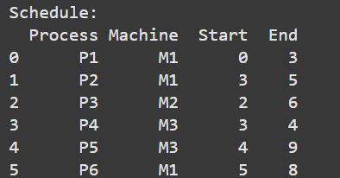

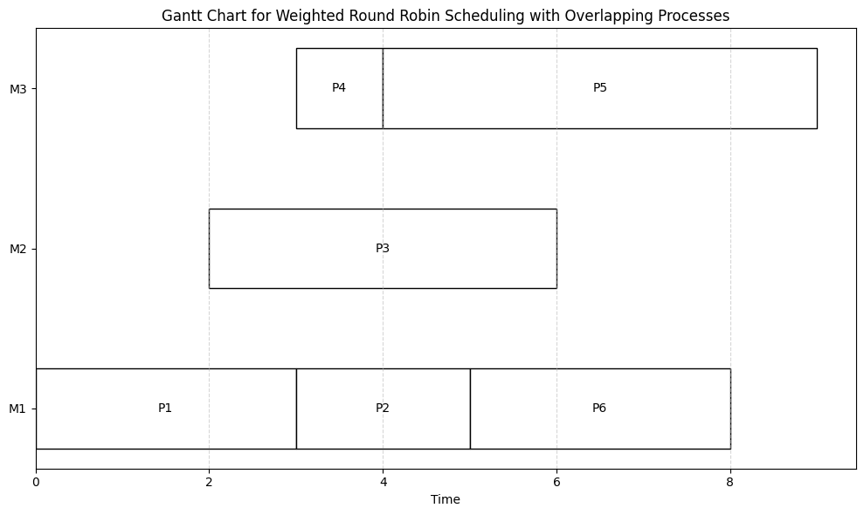

Program 7

Aim: Write code for Ant Colony Optimization

import numpy as np

import networkx as nx

import matplotlib.pyplot as plt

from collections import defaultdict

NUM_ANTS = 10

NUM_ITERATIONS = 100

ALPHA = 1.0

BETA = 5.0

EVAPORATION_RATE = 0.5

Q = 10

def create_graph():

    G = nx.complete_graph(5)

    pos = nx.spring_layout(G)

    weights = {edge: np.random.randint(1, 10) for edge in G.edges()}

    nx.set_edge_attributes(G, weights, 'weight')

    return G, pos

def initialize_pheromones(graph):

    return {edge: 1 for edge in graph.edges()}

def select_next_city(current_city, unvisited, pheromones, distances):

    probabilities = []

    total = 0

    for city in unvisited:

        pheromone = pheromones[(min(current_city, city), max(current_city, city))]

        distance = distances[(min(current_city, city), max(current_city, city))]

        prob = (pheromone * ALPHA) * ((1 / distance) * BETA)

        probabilities.append((city, prob))

        total += prob

    probabilities = [(city, prob / total) for city, prob in probabilities]

    next_city = np.random.choice([city for city, _ in probabilities],

                                 p=[prob for _, prob in probabilities])

    return next_city

def update_pheromones(pheromones, ants_paths, distances):

    for edge in pheromones:

        pheromones[edge] *= (1 - EVAPORATION_RATE)

    for path, length in ants_paths:

        for i in range(len(path) - 1):

            edge = (min(path[i], path[i + 1]), max(path[i], path[i + 1]))

            pheromones[edge] += Q / length

def ant_colony_optimization(graph, num_ants, num_iterations):

    pheromones = initialize_pheromones(graph)

    distances = nx.get_edge_attributes(graph, 'weight')

    best_path = None

    best_length = float('inf')

    for _ in range(num_iterations):

        ants_paths = []

        for _ in range(num_ants):

            path = [0]

            unvisited = set(graph.nodes) - {0}

            while unvisited:

                current_city = path[-1]

                next_city = select_next_city(current_city, unvisited, pheromones, distances)

                path.append(next_city)

                unvisited.remove(next_city)

            path.append(path[0])

            length = sum(distances[(min(path[i], path[i + 1]), max(path[i], path[i + 1]))]

                         for i in range(len(path) - 1))

            ants_paths.append((path, length))

            if length < best_length:

                best_length = length

                best_path = path

        update_pheromones(pheromones, ants_paths, distances)

    return best_path, best_length

def visualize(graph, pos, path):

    plt.figure(figsize=(8, 6))

    nx.draw(graph, pos, with_labels=True, node_color='lightblue', node_size=700, font_size=12)

    edge_labels = nx.get_edge_attributes(graph, 'weight')

    nx.draw_networkx_edge_labels(graph, pos, edge_labels=edge_labels, font_color='red')

    path_edges = [(path[i], path[i + 1]) for i in range(len(path) - 1)]

    nx.draw_networkx_edges(graph, pos, edgelist=path_edges, width=3, edge_color='blue')

    plt.title(f"Best Path with Length: {best_length}")

    plt.show()

graph, pos = create_graph()

best_path, best_length = ant_colony_optimization(graph, NUM_ANTS, NUM_ITERATIONS)

print(f"Best path: {best_path} with length {best_length}")

visualize(graph, pos, best_path)

Best path: [0, 3, 1, 2, 4, 0] with length 12

